# **SHOPNEST SALES REPORT**

# TOP CATEGORIES BY TOTAL PRICE

**Question Statement :**

Identify and visually represent the top 10 product categories by total sales

**Visualization**

**:**

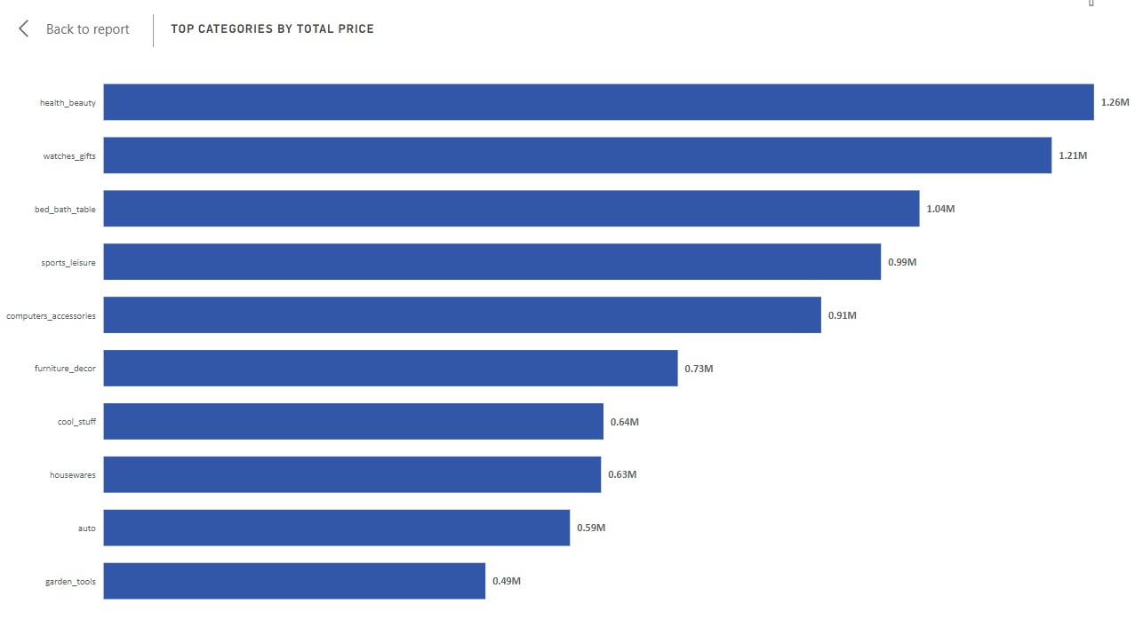

**Explanation :**

The **bar chart** in Power BI highlights the **top 10 product categories** by total sales, offering valuable insights into revenue generation and consumer demand patterns.

Among these categories, **Health & Beauty (beleza_saude)** emerges as the **top performer**, generating **$1.26 million in sales**. It is closely followed by **Watches & Gifts (relogios_presentes)** at **$1.21 million** and **Bed, Bath & Table (cama_mesa_banho)** at **$1.04 million**. Additionally, **Sports & Leisure (esporte_lazer)** and **Furniture & Décor (informatica_acessorios)** demonstrate strong performance, each exceeding **$0.9 million** in total sales.

Meanwhile, **Garden Tools (ferramentas_jardim)** and **Automotive (automotivo)** categories also exhibit notable sales contributions, amounting to **$0.49 million** and **$0.59 million**, respectively. These figures illustrate the diversity in consumer spending preferences, ranging from personal care and lifestyle products to home improvement and automotive essentials.

**Strategic Implications**

This visualization provides key insights for **business strategy and decision-making**, enabling organizations to:

* **Optimize Inventory Management**: Ensure high-demand products remain well-stocked to prevent stockouts and lost sales.
* **Enhance Marketing Strategies**: Focus promotions and advertising efforts on high-performing categories to sustain growth.
* **Expand Product Offerings**: Introduce complementary products in thriving categories to maximize cross-selling opportunities.

**Strengthen Customer Engagement**: Leverage insights to personalize marketing efforts and enhance customer loyalty programs.

# 

# **DELAYED ORDERS ANALYSIS**

**Question Statement :**

Determine the number of delayed orders in each category. An order is considered delayed if the actual delivery date is later than the estimated delivery date.

**Visualization**

**:**

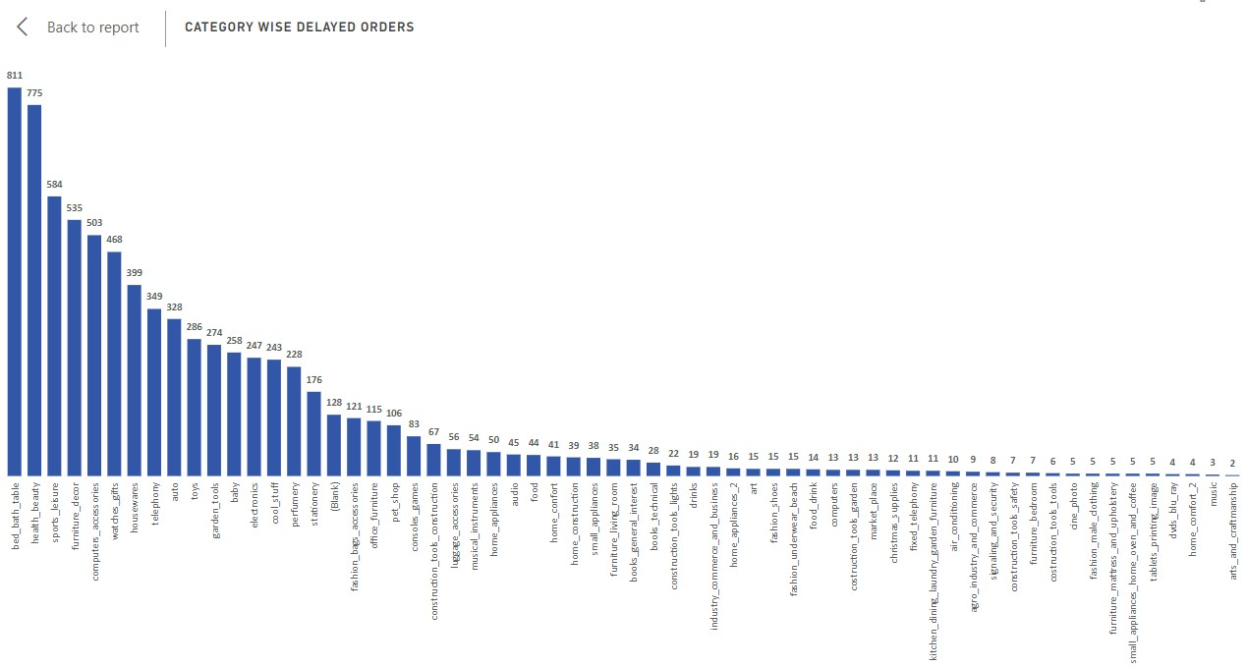

**Explanation :**

The **bar chart** provides a detailed breakdown of **delayed orders** across various product categories, offering critical insights into **fulfillment efficiency and supply chain performance**.

**Key Findings:**

* **Highest Delays:** The **"Bed, Bath & Table"** category experiences the most significant delays, with **811 orders delayed**, pointing to potential **logistics and supply chain challenges**.
* **Other High-Delay Categories:**
  + **Health & Beauty (775 delayed orders)** and **Sports & Leisure (584 delayed orders)** also face substantial fulfillment issues, indicating the need for **better coordination and streamlined delivery processes**.
  + **Furniture & Décor (535 orders), Computer Accessories (503 orders), and Watches & Gifts (468 orders)** also exhibit considerable delays, suggesting systemic inefficiencies requiring immediate attention.
* **Minimal Delays:** In contrast, **Diapers & Hygiene** and **Flowers** categories show **only one delayed order each**, highlighting efficient handling and reliable fulfillment processes.

**Implications & Business Strategy:**

This analysis provides **actionable insights** for improving logistics and delivery processes:

1. **Addressing Supply Chain Bottlenecks**: Categories like **Home Appliances (50 delayed orders)** and **Electronics (247 delayed orders)** may benefit from **better inventory forecasting and replenishment strategies** to prevent stockouts and delays.
2. **Optimizing Order Processing**: High-delay categories may require **improved warehouse operations, better supplier coordination, or alternative shipping solutions**.

**Prioritizing Operational Efficiency**: Understanding the root causes of delays enables businesses to implement **corrective measures, allocate resources efficiently, and enhance customer satisfaction**.

# 

# **MONTHLY COMPARISON OF DELAYED AND ON-TIME ORDERS**

**Question Statement :**

Create a dynamic visual that compares the number of delayed orders to the number of orders received earlier for each month. Utilize the drillthrough cross-report feature to provide a detailed analysis of late and on-time deliveries.

**Visualizat**

**ion**

**:**

**Explanation**

**:**

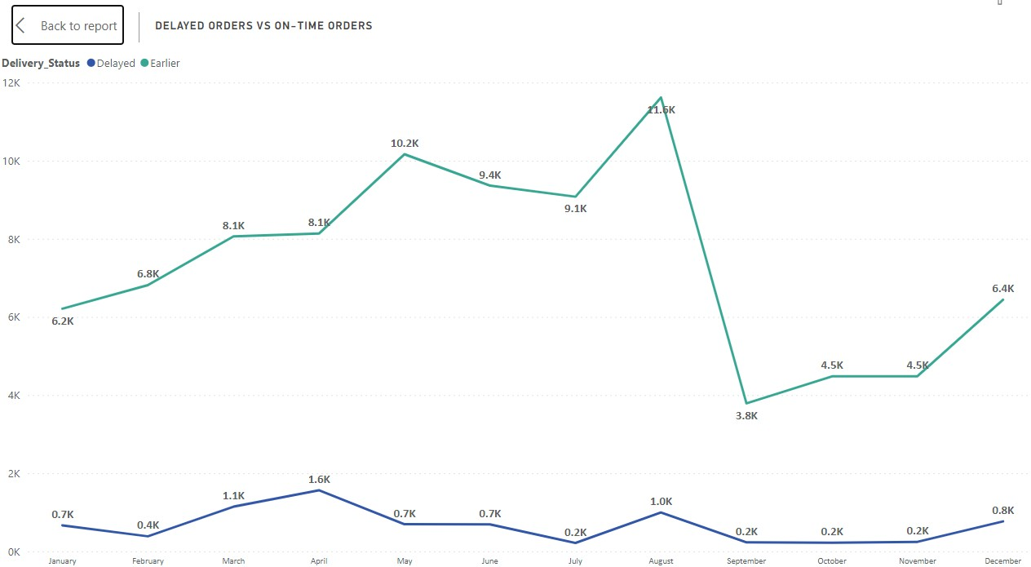

The **line chart** provides a comparative analysis of **delayed vs. earlier orders** across all months, offering key insights into **order fulfillment efficiency** throughout the year.

**Key Findings:**

* **Best Performance (August):** August stands out with the **largest gap** between earlier and delayed orders, with **11,620 earlier orders** compared to **only 996 delayed orders**, highlighting **exceptional efficiency** in meeting customer demands.
* **Smallest Gap (July):** July records the **narrowest margin** between earlier and delayed orders, with **9,078 earlier orders** slightly exceeding **216 delayed orders**, maintaining a strong fulfillment rate.
* **Consistent Trends (September to November):**
  + **September:** 3,790 earlier orders vs. 231 delayed
  + **October:** 4,480 earlier orders vs. 222 delayed
  + **November:** 4,483 earlier orders vs. 245 delayed  
    These findings reinforce the organization's **consistent performance in fulfilling orders promptly** across these months.
* **Seasonal Impact (December & January):**
  + **December (767 delayed orders) and January (667 delayed orders)** show a noticeable increase in delays, likely due to **higher order volumes during the holiday season**, causing logistical bottlenecks.
* **Strong Performance (May & June):**
  + **May (696 delayed orders) and June (691 delayed orders)** exhibit **lower delays**, indicating **efficient order processing and logistics management** during these periods.

**Business Implications & Strategic Actions:**

* **Peak Season Readiness:** The increase in delays during **December and January** suggests the need for **enhanced logistics planning, inventory stocking, and workforce allocation** to handle holiday demand effectively.
* **Operational Efficiency:** Months with **fewer delays (August, May, June)** can serve as benchmarks for identifying **best practices in fulfillment and logistics**.

**Resource Optimization:** The organization can leverage these insights to **allocate resources proactively, improve supply chain coordination, and streamline order processing**, ultimately **enhancing customer satisfaction and loyalty**.

# 

# **PAYMENT METHOD ANALYSIS**

**Question Statement :**

Analyze the most frequently used payment methods by customers using a visually appealing representation, such as a pie chart or other suitable visuals.

**Visualization**

**:**

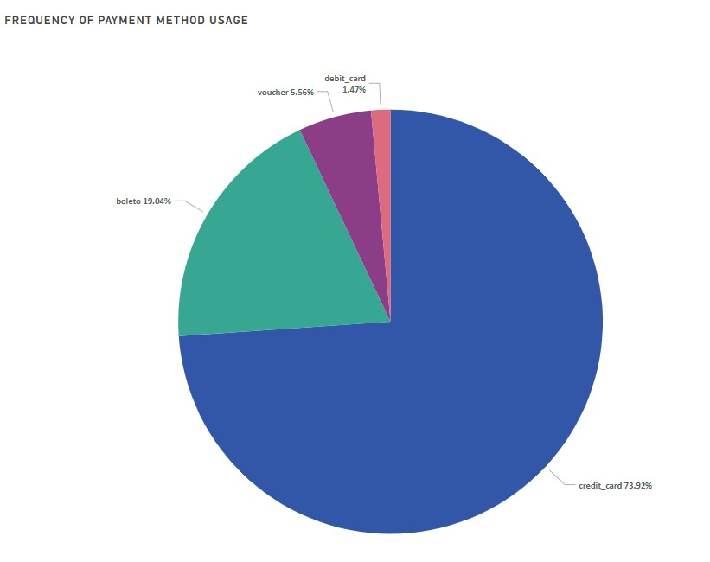

**Explanation :**

The **pie chart** provides a concise overview of **customer payment preferences**, offering key insights into transaction behaviors and the distribution of payment types among customers.

**Key Findings:**

* **Credit Card – The Dominant Payment Method:**
  + **76,795 customers (73.9%)** opt for credit cards, making it the **most widely used payment option**. This dominance suggests a strong preference for **convenience, security, and flexibility**, particularly for installment-based purchases.
* **Boleto – The Second Most Popular Choice:**
  + **19,784 customers (19.0%)** prefer the **boleto payment method**, reflecting a significant segment of customers who favor **alternative payment solutions, possibly due to banking restrictions or preference for offline transactions**.
* **Voucher & Debit Card – Niche but Noteworthy:**
  + **Voucher payments account for 5,775 customers (5.6%)**, indicating usage among specific customer groups, possibly due to employer benefits or prepaid options.
  + **Debit card transactions are used by 1,529 customers (1.5%)**, representing a smaller yet significant segment that prefers direct payments from bank accounts.

**Business Implications & Strategic Actions:**

* **Enhancing Payment Processing & Flexibility:**
  + With **credit cards leading transactions**, businesses should ensure **secure and seamless processing, installment payment options, and fraud prevention measures** to enhance customer trust.
* **Optimizing Alternative Payment Methods:**
  + The **substantial use of boleto** indicates a need for **efficient processing and timely reconciliation** to reduce payment delays.
  + **Voucher and debit card users**, though a smaller percentage, highlight the importance of **offering diverse payment options** to meet the needs of different customer segments.
* **Strategic Decision-Making for Payment Infrastructure:**

The insights from this **pie chart** help businesses **allocate resources efficiently**, enhance transaction efficiency, and adapt to evolving customer preferences **by expanding payment offerings or optimizing existing ones**.

# **PRODUCT RATING ANALYSIS**

**Question Statement :**

Determine the top 10 highest-rated products and the bottom 10 lowest-rated products using a bar or column chart.

**Visualization :**

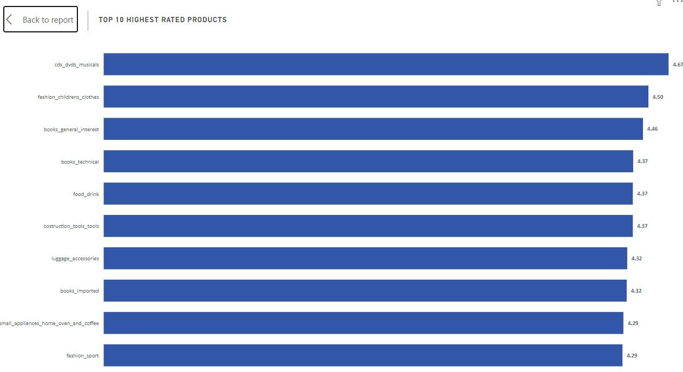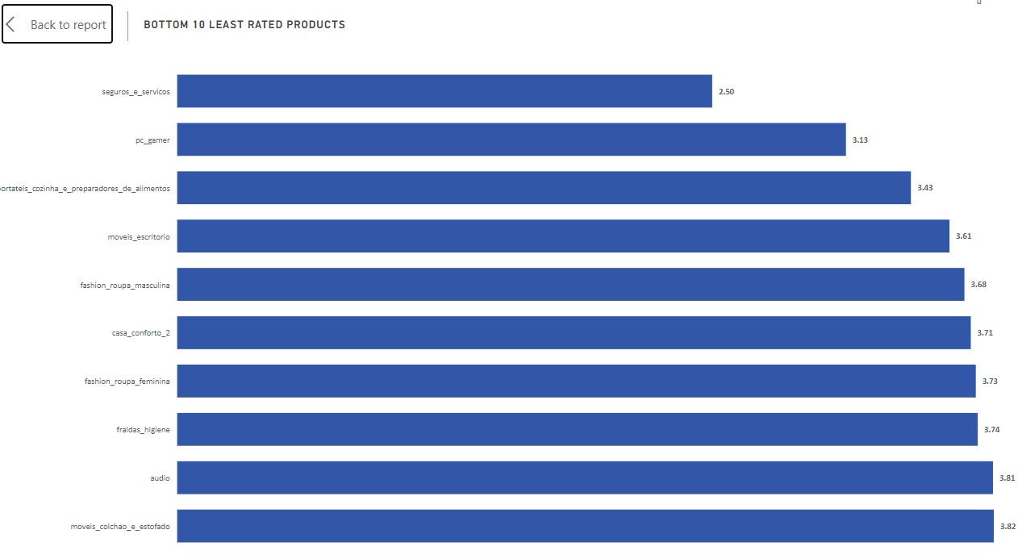

**Explanation :**

The **bar chart** provides a concise overview of the **top 10 highest-rated product categories** based on **average customer ratings**, offering key insights into **customer satisfaction and product appeal**.

**Key Findings:**

* **Highest-Rated Category:**
  + **"CDs, DVDs, and Musicals"** leads with an **impressive average rating of 4.67**, reflecting **exceptional customer satisfaction** and product quality in this segment.
* **Top Contenders:**
  + **"Fashion - Children's Clothes" (4.50)** and **"Books - General Interest" (4.46)** secure the **second and third** positions, indicating **strong consumer appeal** and **high perceived value** in these categories.
* **Consistently High Ratings Across Categories:**
  + **"Books - Technical," "Food & Drink," and "Construction Tools - Tools"** all share an **average rating of 4.37**, demonstrating **consistent customer satisfaction** across these diverse product segments.
  + **"Small Appliances - Home Oven & Coffee" and "Fashion - Sport" (4.29)** further reinforce the trend of **positive customer feedback** in both household and apparel-related categories.
* **Specialized & Premium Offerings:**
  + The presence of **"Books - Imported" and "Luggage & Accessories"** among the **top-rated categories** suggests **consumer demand for premium and specialized products**.

**Business Implications & Strategic Actions:**

* **Product Development & Quality Enhancement:**
  + Businesses can leverage these insights to **maintain and improve product quality** in high-rated categories, ensuring continued customer satisfaction and loyalty.
* **Marketing & Positioning Strategies:**
  + Categories with high ratings, such as **fashion, books, and home appliances**, present opportunities for **targeted promotions, brand positioning, and personalized marketing campaigns** to attract more customers.
* **Customer Sentiment & Loyalty Management:**
  + Consistently **high ratings indicate strong consumer trust**, emphasizing the need to **sustain quality, enhance customer experience, and invest in after-sales support** to reinforce long-term loyalty.
* **Investment in Niche & Premium Segments:**

The demand for **imported books and high-quality luggage accessories** suggests a profitable **opportunity for expanding premium product lines** and catering to specialized consumer preferences.

# **STATE-WISE SALES ANALYSIS**

**Question Statement :**

Identify and visually represent states with high and low sales, providing a clear understanding of regional sales performance.

**Visualization :**

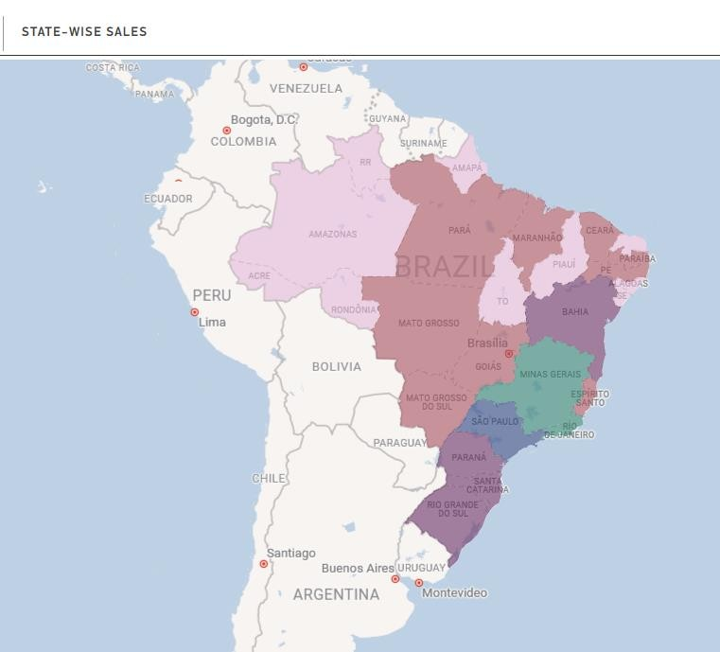

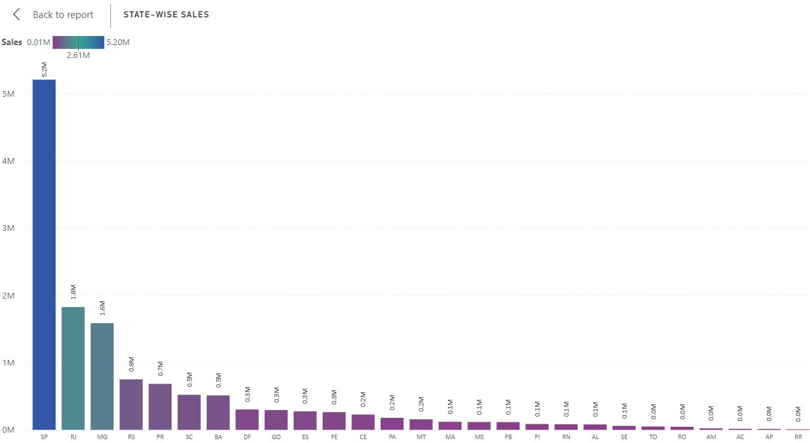

**Explanation :**

The **map chart** provides a comprehensive overview of **sales distribution across various states**, highlighting **significant variations in revenue generation** and regional market dynamics.

**Key Findings:**

* **Top-Performing States:**
  + **São Paulo (SP) leads sales performance**, generating over **$5.20 million**, which accounts for a **dominant 38.3% of total revenue**.
  + **Rio de Janeiro (RJ)** follows, contributing **$1.82 million (13.4%)**, reflecting its significant role in driving overall sales.
  + **Minas Gerais (MG) and Rio Grande do Sul (RS)** also exhibit **notable revenue figures**, with **$1.59 million (11.7%)** and **$0.75 million (5.5%)**, respectively.
* **Lower-Performing States:**
  + States like **Roraima (RR) and Amapá (AP)** record the **lowest sales volumes**, contributing less than **0.1% of total revenue**.
  + **Roraima (RR):** $0.007 million
  + **Amapá (AP):** $0.013 million
* **Regional Sales Trends:**
  + The **gradient representation in the map chart** visually differentiates states based on their sales volumes, clearly identifying **high, medium, and low-revenue regions**.
  + While **São Paulo and Rio de Janeiro drive the majority of sales**, there is **significant potential for market expansion in lower-performing states**.

**Business Implications & Strategic Actions:**

* **Market Expansion Opportunities:**
  + States with **lower sales figures**, such as **Roraima and Amapá**, present **growth opportunities**. Targeted **marketing campaigns, distribution expansion, and localized sales strategies** can help capture untapped demand.
* **Optimizing Resource Allocation:**
  + Given **São Paulo and Rio de Janeiro’s dominance**, businesses should **ensure sustained investment in high-performing regions** while **strategically allocating resources to emerging markets**.
* **Regional Sales Strategies:**
  + **High-sales regions** require **continued customer engagement, competitive pricing strategies, and inventory management** to sustain growth.
  + **Underperforming regions** may benefit from **enhanced logistics, targeted promotions, and partnerships with local retailers** to boost sales.
* **Improving Distribution & Logistics Efficiency:**

Sales trends highlight **regional demand variations**, emphasizing the need for **efficient supply chain management and distribution networks** to **streamline delivery and meet customer expectations** in different regions.

# **SEASONAL SALES PATTERN**

**Question Statement :**

Investigate and visualize any seasonal patterns(Quarterly) or trends in sales data over the course of the year.

**Visualization**

**:**

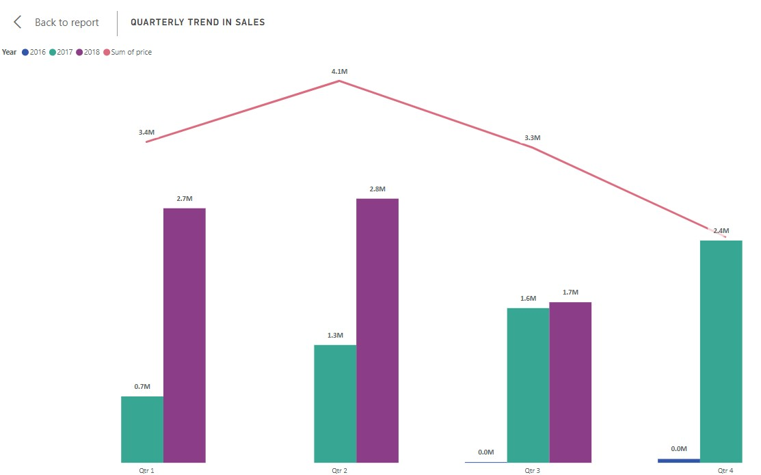

**Explanation :**

The **combo chart** provides a detailed analysis of **quarterly sales performance across different years**, offering key insights into **sales growth, trends, and seasonality**.

**Key Findings:**

* **Consistent Sales Growth:**
  + Sales have shown a **clear upward trend across all quarters**, with notable year-over-year increases.
  + **Q1 Sales Growth:** Increased from **$0.71 million (2017) to $2.7 million (2018)**, demonstrating significant expansion.
  + **Q2 Sales Growth:** Grew from **$1.25 million (2017) to $2.81 million (2018)**, reinforcing strong market demand and business growth.
* **Seasonality in Sales Performance:**
  + The **second quarter (Q2) consistently records the highest sales** across the years, peaking at **$4.1 million**.
  + **Q1 follows with $3.4 million**, while **Q3 records $3.3 million**, highlighting seasonal variations in consumer spending.
* **Visual Representation of Trends:**
  + The **bar chart** showcases quarter-wise sales per year, highlighting fluctuations in individual quarters.
  + The **line chart** complements this by illustrating **total quarterly sales**, providing a **holistic view of overall sales trends** over time.

**Business Implications & Strategic Actions:**

* **Capitalizing on Peak Sales Periods:**
  + With **Q2 consistently generating the highest sales**, businesses should **align marketing campaigns, inventory planning, and promotional strategies** to leverage peak consumer demand.
* **Sustaining Growth in Off-Peak Quarters:**
  + While Q1 and Q3 also demonstrate strong sales, targeted **promotional efforts and demand forecasting** can help maintain sales momentum throughout the year.
* **Strategic Resource Allocation:**
  + The **quarterly variations underscore the need for efficient workforce management, stock replenishment, and financial planning** to optimize revenue streams across different periods.
* **Identifying Growth Opportunities:**

The **continuous sales growth across years** suggests a positive market response, indicating potential opportunities for **expansion, diversification, and investment in high-performing product categories**.

# **REVENUE ANALYSIS**

**Question Statement :**

Determine the total revenue generated by ShopNest Store and analyze how it changes over time(Yearly). Represent this information through suitable visuals to highlight trends and patterns.

**Visualization**

**:**

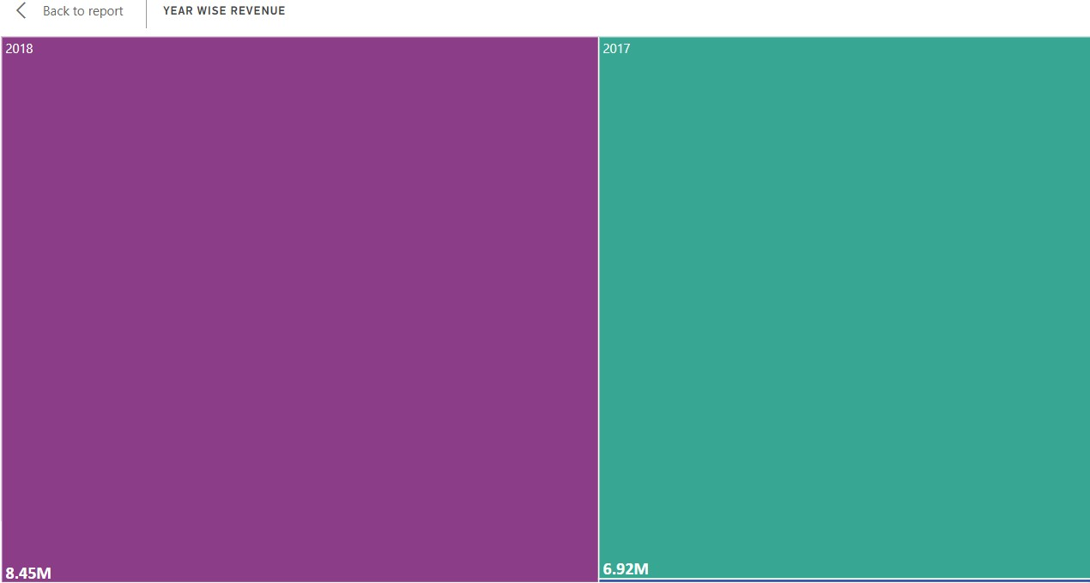

**Explanation :**

The **tree chart** provides a **clear visual representation of revenue trends**, offering key insights into **year-over-year revenue growth** and business performance.

**Key Findings:**

* **Substantial Revenue Growth (2016 - 2017):**
  + Revenue surged from **$47K in 2016 to $6.92 million in 2017**, marking a **remarkable growth trajectory**.
  + This **exponential increase** highlights **strong market expansion, effective business strategies, and favorable industry conditions**.
* **Continued Upward Trend (2017 - 2018):**
  + Revenue continued to rise, reaching **$8.45 million in 2018**, reinforcing **sustained business success** and the ability to **capitalize on growth opportunities**.
  + The increase between **2017 and 2018 reflects adaptability, strategic investments, and enhanced operational efficiency**.

**Business Implications & Strategic Actions:**

* **Market Expansion & Competitive Advantage:**
  + The **sharp revenue growth** suggests **effective market penetration strategies**, positioning the business strongly against competitors.
* **Sustaining Growth Momentum:**
  + To maintain this growth, businesses should **leverage high-performing revenue channels, optimize product offerings, and explore new markets**.
* **Investment in Scalability:**
  + With a proven growth trajectory, **investment in infrastructure, technology, and workforce expansion** can further support scalability.
* **Revenue Diversification:**

Identifying **key revenue drivers and potential risks** will help businesses **diversify income sources and mitigate dependency on specific markets or products**.

# 

# **CONCLUSION**

**Regional Sales Performance:**

By analyzing state-wise sales performance, it's evident that certain regions, such as São Paulo and Rio de Janeiro, significantly contribute to overall revenue generation. Strategic focus on key markets and exploration of growth opportunities in regions with lower sales figures can further bolster sales performance.

**Fulfillment Efficiency:**

The analysis of delayed orders reveals insights into fulfillment efficiency, highlighting potential challenges in logistics and supply chain management. Addressing systemic issues and streamlining processes can enhance order fulfillment and customer satisfaction.

**Seasonal Sales Trends:**

Seasonal sales patterns exhibit distinct trends across different quarters, emphasizing the importance of strategic planning to capitalize on peak periods of consumer spending. Understanding seasonality enables businesses to optimize resource allocation and sales strategies for sustained growth throughout the year.

**Payment Method Preferences:**

Credit card emerges as the dominant payment method, indicating a preference for convenience and flexibility among customers.Offering diverse payment options caters to varying customer preferences and enhances transaction efficiency.

**Product Satisfaction:**

Analysis of product ratings underscores the significance of product quality and customer experience in driving satisfaction and loyalty. Leveraging insights into top-rated products enables businesses to refine offerings and prioritize investments for enhanced customer satisfaction.

**Revenue Growth and Trends:**

Revenue analysis over time reveals substantial growth trajectories, reflecting positive market dynamics and effective business strategies. Continued revenue growth underscores the organization's adaptability and ability to capitalize on opportunities for sustained success.

**Strategic Implications:**

The insights gathered from these analyses provide valuable guidance for strategic decision-making, resource allocation, and operational enhancements.By leveraging actionable intelligence, organizations can refine processes, optimize sales strategies, and drive sustained business growth and profitability in the competitive e-commerce landscape.

In conclusion, a comprehensive understanding of sales performance, fulfillment efficiency, customer preferences, and revenue trends empowers businesses to make informed decisions and implement targeted strategies for sustained success and competitive advantage in the dynamic e-commerce market.